**Assignment 5**

Task1 : Write a program that get the number from user and calculate the Multiplication table

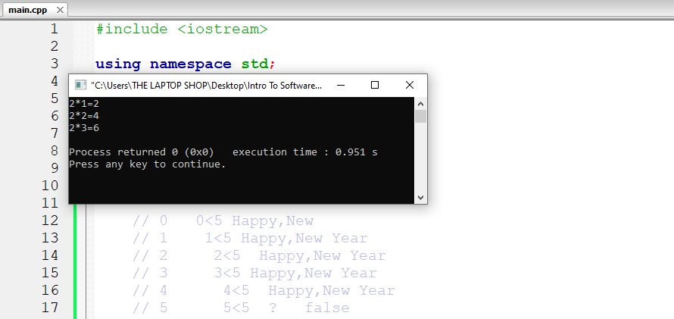Of that program using while loop, and write the trace of that program in a paper or in word file.

Task2:Write a program that take the month you born in and print who famous will you meet depend on the month you born in using switch case